Soumya Shanigarapu

Indiana University Indianapolis, [sshanig@iu.edu](mailto:sshanig@iu.edu)

Teja Vineeth Reddy YeramaReddy

Indiana University Indianapolis, [tyerama@iu.edu](mailto:tyerama@iu.edu)

Supraja Pericherla

Indiana University Indianapolis, [sperich@iu.edu](mailto:sperich@iu.edu)

Maniteja Ladi

Indiana University Indianapolis,[maniladi@iu.du](mailto:maniladi@iu.du)

Ganesh Gude

Indiana University Indianapolis, gudeg@iu.edu

Hemanth Kumar Reddy Gunnam

Indiana University Indianapolis, hgunnam@iu.edu

**ABSTRACT**

Recipe Treasury System is an online-based system aimed at providing personalized recommendations for the user towards a richer experience in their cooking sessions. This is set to address the challenge toward access to a variety of global recipes, which has been so much limited, and offers suggestions tailor-made by taste preferences. The system is a human-friendly interface for searching for recipes, detailed information on recipes, user registration/login, and commenting system. The collected data will involve recipe recommendations, recipe details, and comments made from the users. Going forward, there is a need for future development in data standardization, improving UI design, personalized nutritional tracking, and the addition of cooking AI assistants, AR recipe experience. These initiatives are expected to include social cooking communities and offer voice-activated assistance.

**TABLE OF CONTENTS**

|  |  |
| --- | --- |
| CONTENTS | PAGE NUMBER |
| 1. Introduction | 3 |
| 2. Description | 4 |
| 2.1 Blog | 4 |
| 2.2 User Portal | 4 |
| 2.3 Admin Privileges | 4 |
| 3. Interaction With Website | 5 |
| 3.1 Homepage | 5 |
| 3.2. User registration/Login | 5 |
| 4. Key Functionality | 7 |
| 5. Languages and Tools used | 7 |
| 6 Data Collected | 8 |
| 7. Code Components | 8 |
| 8. Database Design | 8 |
| 9. Summary | 11 |
| 10. Limitations and Future Work | 12 |
| 11. References | 13 |

# **INTRODUCTION**

The Recipe Treasury system is an innovative platform designed to provide users with personalized recipe ideas based on their preferences and requirements. By allowing users to input their requirements and offer tailored recipe suggestions to enhance their cooking experience.

* 1. MOTIVATION

The motivation behind the Recipe Treasury System is twofold:

**Global Culinary Exploration:** The major objective is to provide a collection of recipes from around the world, allowing the user to explore and cook diversely prepared ditheys. This program is meant for those with a passion for food and who would want to take up world cuisines, from Italian pastas to Asian stir-fries and Middle Eastern wraps. It aims to bring the tastes of the world, whether it be non-vegetarian or vegan dietary preferences, into the user's kitchen.

**Personalized Recipe Recommendations**: This is amongst the main aims of the website. It aims to personalize recipes for the user to enhance the cooking experience of the user. This has been actualized through an ingenious recommendation system that delves into the users' dietary requirements, culinary tastes, and history of the interactions they made on the platform. The idea is to personalize the cooking experience around individual tastes and dietary needs; hence, it becomes easy for the user to locate a recipe that very much emulates their lifestyle and culinary history.

* 1. PROBLEM

The website is attempting to solve the problem of lack of access to varied and global recipes that can be customized per individual dietary preferences. The website solves the personalization problem of cooking by availing user recipes that match their tastes through a modern recommendation algorithm.

* 1. TARGET AUDIENCE

The Recipe Treasury System’s user base is as diverse as the recipes it offers:

* **At-home Cooks:** Individuals looking to spice up their home dining with new and exciting recipes.
* **Busy Professionals:** Those who need to fit cooking into a hectic schedule without compromising on health or taste.
* **Health Enthusiasts:** Fitness-minded users seeking recipes that align with their dietary and health goals.
* **Foodies:** Culinary aficionados in search of authentic and novel cooking experiences.
* **Beginner Cooks:** New chefs seeking guidance to develop their culinary skills with easy-to-follow recipes.

# **DESCRIPTION**

The Recipe Recommendation Website offers a user-friendly interface where users can easily input their requirements and receive customized recipe suggestions. Here's a breakdown of its key features and functionality:

**2.1 BLOG:**

**2.1.1 Homepage:**

In this section, users can access the website and view recipes uploaded by other users without needing to create an account.

**2.1.2 Recipe Search:**

Users can search for recipes based on various criteria such as type of meal they want to eat, cooking time or number of people they want to make the food for (breakfast, lunch, dinner, snacks), and specific ingredients.

**2.1.3 Recipe Details:**

* Each recommended recipe includes detailed instructions, ingredient lists, nutritional information, and sometimes user reviews.
* Users can also review recipes they have tried, contributing to the community aspect of the website.

**2.2 USER PORTAL:**

**2.2.1 User Registration and Login:**

* Users can create an account or log in using their existing credentials.
* Registration allows users to post a recipe or to comment on the available recipes, activity, and our own tailored recipe recommendation system.

**2.2.2 Recipe Recommendations:**

* After inputting their requirements, users receive personalized recipe recommendations that match their preferences, which are built on various machine learning methods.
* Recommendations are generated based on a combination of user input and algorithmic analysis of recipe data.

**2.3 ADMIN PRIVILEGES:**

**2.3.1 Interaction:**

* Users can leave comments on recipes they have tried or viewed. Comments are moderated to ensure a positive and constructive environment. Users may report inappropriate comments, and moderators can remove or edit comments if necessary.
* Users have profiles where they can view their comment history and interact with other users

**2.3.2 Responsive Design:**

The website is optimized for both desktop and mobile devices, ensuring a seamless user experience across different platforms.

# **INTERACTION WITH WEBSITE**

**3.1 Homepage:**

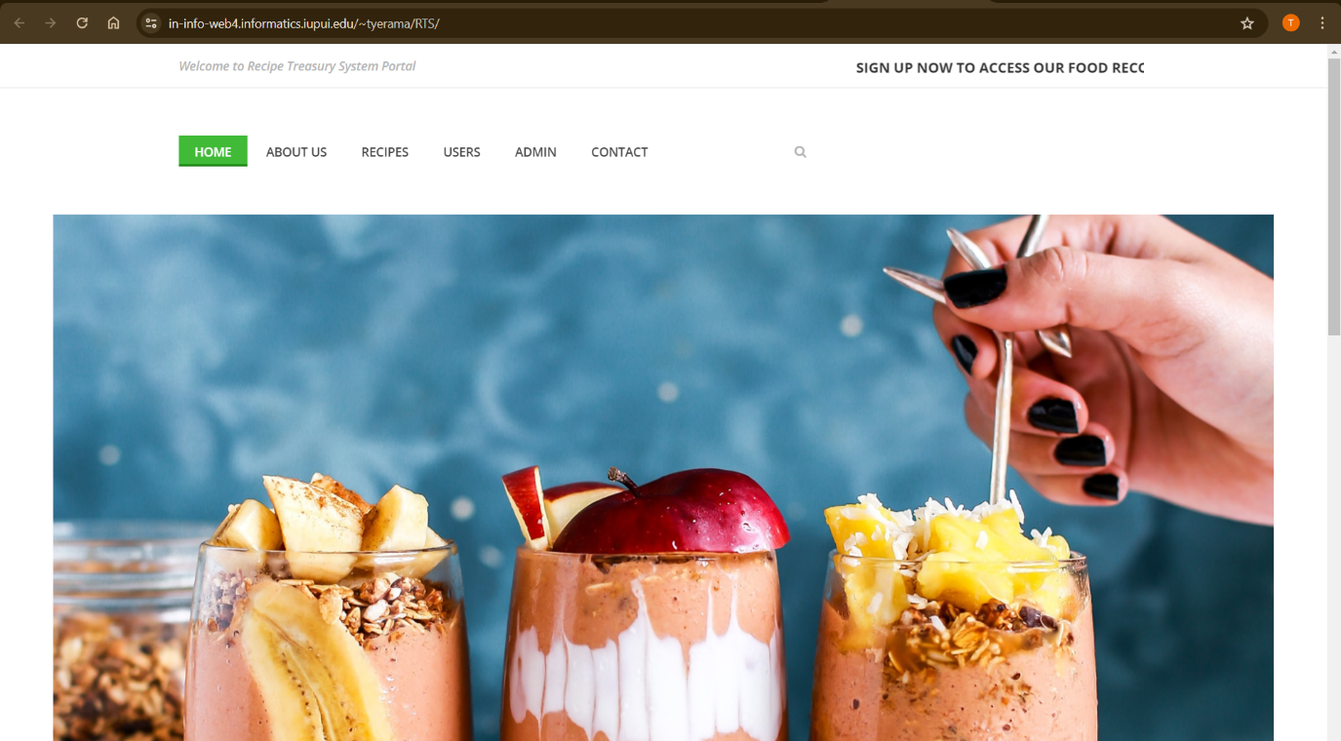 **Figure 1: Image showing the homepage of main website**

A user, a food enthusiast accesses the [website](https://in-info-web4.informatics.iupui.edu/~tyerama/RTS/). They can quickly glance at the homepage without needing to create an account. Here, they can view listed recipes, comment on them, leave a review, or contact the admin team through the website.

**3.1.1 Exploring Recipe Details:**

Users can click on a recipe to view more details. They see the ingredients list, step-by-step instructions, cooking time, preparation time, etc. Additionally, they can leave a comment on a recipe.

**3.1.2 Interactive Design:**

On the homepage, users have the option to search for recipes in the portal or send an inquiry to the admin team about the website

**3.2 User Registration/Login:**

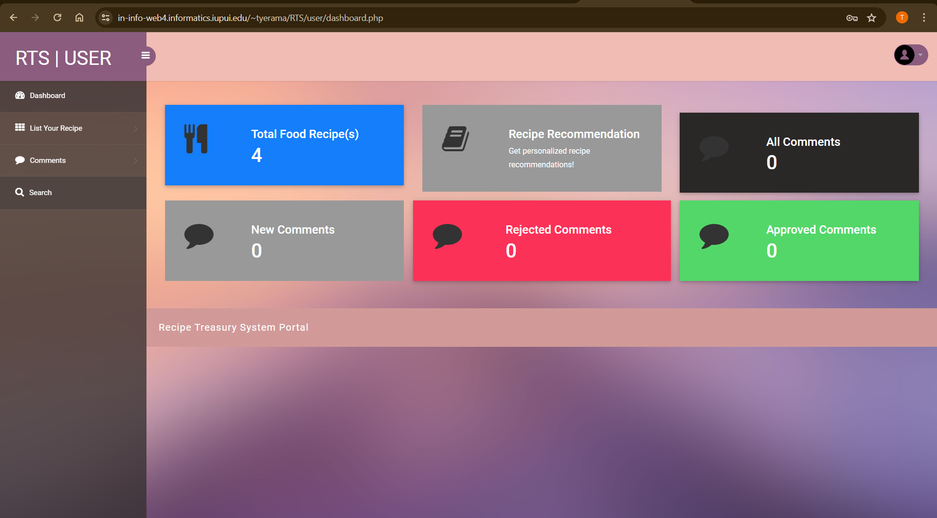 **Figure 2: Image displaying the user dashboard after logging into their account.**

After reviewing the website or taking a quick peek, users can create a user account with their email and personal information, which will be stored in the backend using our database. They can then login, create a new password, and access the user portal, where they can do much more.

**3.1.1 Recipe Management:**

* In the portal, users can upload a personalized recipe by inputting the required fields. They can also edit/delete the recipes they have shared on the portal and view comments on their recipes.

**3.1.2 Receiving Recommendations:**

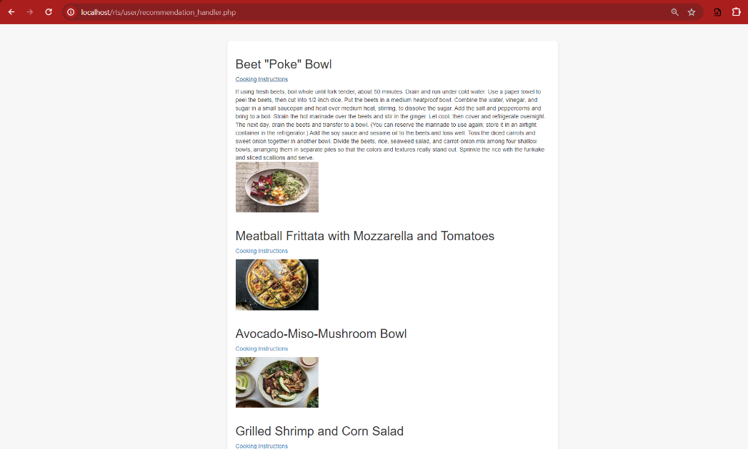

**Figure 3: Image displaying recipe recommendation results after user selects ingredient**.

If users want the portal to suggest recipes, it is tailored with machine learning methods to recommend a recipe based on their preferences.

# **KEY Functionalities**

**4.1 Personalized Recommendations:**

Using machine learning methods like TF-IDF and Cosine Similarity, we have created a recipe recommendation portal that allows users to get recipes based on their cravings, preparation time, and servings. Users need to enter details requested on the website, such as craving item, preparation time, and servings, to receive the top 5 dishes that match their craving

**4.2 Detailed Recipe Information:**

We've created a page where users can share their recipes by entering all details like cooking preparation time, ingredients, etc. This not only shares with everyone but also allows users to access the recipe anytime in their account.

**4.3 Commenting System:**

We have a section on the homepage where people can comment on various recipes, letting others know about their opinions.

**4.4 Responsive Design:**

The website is optimized for both desktop and mobile devices, ensuring a seamless user experience.

# **LANGUAGES AND TOOLS USED**

* **PHP:** This is the script language empowering the server-based parts, such as ‘**index.php’** and ‘**recipes.php’**. It takes place in carrying out all the sessions, database interrelations, and finally forming HTML dynamically.
* **HTML/CSS and Bootstrap:** HTML is used in the construction of the web page structure, while CSS is utilized to add layout and theme to the given structure. Bootstrap offers responsive design from devices on themes and grid layouts.
* **JavaScript:** Used in the ‘**js’** directory, this programming language adds interactivity with a possibility to deal with events, form validation, and asynchronous updates in the user interface via AJAX for an improved user experience without refreshing the entire page.
* **SQL**: Used in PHP scripts for all our database functionalities, such as **JSON** retrieval, updating, and storage requirements for features like search and content management.
* **Sass:** Used in the ‘**scss’** directory for advanced styling, which is compiled to CSS to make the design more appealing and device responsive.
* **Web Server (e.g., Apache, Nginx):** Web servers designed to process all incoming request and serve content that has been generated by PHP to the user, in short acting as mediators between server-side processing and user.
* **Database Management System (phpMyAdmin):** In cohesion with PHP, this will manage where data is stored, retrieved, and secured, giving room for the handling of data-intensive operations like users, recipes etc.
* **Development Tools (IDEs, text editors):** Development tools, such as Integrated Development Environments (IDEs) and text editors, help write and modify the project code, test, and ensure effective development practices for durable maintainable code within the entire codebase.

# **6 DATA COLLECTED**

For this Project we collected datasets including

**6.1 Recipe Recommendations:**

We collected a dataset for recipe recommendations based on users' cravings, cooking time, and servings from Kaggle.

Link to the dataset: [Food Ingredients and Recipes Dataset with Images](https://www.kaggle.com/datasets/pes12017000148/food-ingredients-and-recipe-dataset-with-images)

**Additionally, we gathered data from users' opinions and feedback on the recipes.**

**6.2 Recipe Details:**

Users are allowed to share or create detailed information about recipes, including ingredients, instructions, cooking time, etc. This data is stored in our database to show other users about this recipe.

**6.3 User Comments:**

Users can see comments left by others on the recipe pages, providing additional insights and feedback on the recipes. This data is stored in our database to show recipe reviews based on users' comments.

**6.4 Admin Portal:**

When users provide comments for recipes, the admin has access to either approve or reject them. This allows users to get relevant feedback on their recipes.

# **7 CODE COMPONENTS**

The main components of the portal are as follows (without including the styling, fonts, images etc) :

**7.1 Common Components:**

1. dbconnection.php - The PHP script attempts to establish a connection to a MySQL database
2. topbar.php - This is a preloader displaying icons during page loads, and a search interface for submitting recipe names to `search.php` with a close button.
3. footer.php - This defines a footer area that includes social media links and a footer logo linking to "index.php".
4. header.php. - This is the website header for our "Recipe Treasury System Portal" that includes a top header area with a scrolling marquee text urging users to sign up. It also features a navigation bar with links to various pages like Home, About Us, Recipes, User and Admin login, and Contact.

**7.2 Homepage:**

1. about.php - This is used to fetch content from ‘tblpages’ where the `PageType` is 'aboutus'. This dynamically loads the appropriate content into the page based on database entries.
2. contact.php - This PHP file handles the form submission from a contact page, collecting user data and inserts them into the 'tblenquiry' table in the database.
3. index.php - This is the main homepage file for the "Recipe Treasury System", featuring dynamic content sections like a hero slider with background images and a recipe listing area that displays the most recently added recipes.
4. recipe-details.php - This PHP file manages the display of detailed information for a specific recipe. It also handles user comment submissions with form data validation and inserts comments into the 'tblcomments' table in the database.
5. recipes.php - It features an Instagram gallery to showcase culinary images and integrates common components like the header, footer, and top bar.
6. search.php - This PHP file processes user search queries by fetching recipes that match the search keyword from the database. It displays search results with recipe information.

**7.3 User/Admin Portal:**

**7.3.1 Common files:**

1. Add-recipe.php - This PHP file is designed for logged-in users to submit new recipes. If the recipe is added successfully, it redirects to the same page with a success message, otherwise, it shows an error message.
2. All-comments.php - This PHP file serves as a dashboard for users to view all comments made on their recipes. Users can interact with comments, seeing their approval status and directly navigating to edit specific recipes.
3. Approved-comments.php - This PHP file is specifically designed for users to view approved comments on their recipes. The page displays a table of comments that have been approved.
4. Change-password.php - This PHP file facilitates password changes for logged-in users. The script checks the user's current password against the database, and if it matches, updates to the new password.
5. Dashboard.php - This PHP file serves as the main dashboard for logged-in users. The dashboard displays various statistics including the total number of recipes posted by the user, comments on those recipes, and provides quick access to recipe recommendations.
6. Edit-recipe.php - This PHP file allows logged-in users to update their recipe details. The interface facilitates adding or removing ingredients dynamically and displays existing recipe details for editing.
7. Forgot-password.php - This PHP file enables users to initiate a password reset process. It verifies user identity using an email and mobile number combination. The form supports direct navigation to the login page and the home page for further actions.
8. Index.php - Homepage for both user/admin portal.
9. Login.php - PHP code for login validation using the details from backend database.
10. Logout.php - PHP code for logout from the session.
11. Manage-recipes.php - This PHP file provides a management interface for users logged in to view, edit, and delete their recipe entries. It includes functionality to delete recipes directly from the database.
12. New-comments.php - This PHP file displays newly received comments that are pending approval. It offers a comprehensive view for the user to manage comments associated with their recipes, indicating the status of each comment as "Waiting for Approval."
13. Profile.php - This PHP file allows users to update their personal details. Users can modify their full name and mobile number. The file includes form validation and submits the changes to the database.
14. Rejected-comments.php - This PHP file provides users to view comments on their recipes that have been marked as rejected.
15. Reset-password.php - This PHP file gives the capability for users to reset their password.

**7.3.2 User Exclusive:**

Recipe-recommendation-dashboard.php - This PHP file serves as a dashboard for users logged into the Recipe Treasury System who are seeking personalized recipe recommendations. The dashboard allows users to input their preferences such as the type of dish they want to eat, preparation time, and the number of people to serve. The user's preferences are submitted to a recommendation handler script, which processes the input and generates suitable recipe suggestions.

Recommendation_handler.php - This HTML page serves as a user interface for displaying recipe recommendations based on user inputs. It integrates a Python script to generate these recommendations, which are then dynamically rendered within the page. The layout uses Bootstrap for styling, and custom JavaScript with jQuery for interactive elements like toggling recipe details.

ML_rcmnd.py - This Python script connects to a MySQL database using pymysql, fetches recipe data from the table `tblrcmd`, and stores it in a pandas Data Frame. It then combines ingredients and titles into a single text column for TF-IDF vectorization, which is used to compute cosine similarity between recipes for recommending similar items. The function `get_recommendations` filters and recommends recipes based on title similarity or ingredient matches, adjusting for preparation time and serving size. If executed directly (not imported), the script takes command-line arguments for query parameters, generates recipe recommendations, and constructs an HTML page displaying the results with toggleable instructions and images.

# **DATABASE DESIGN**

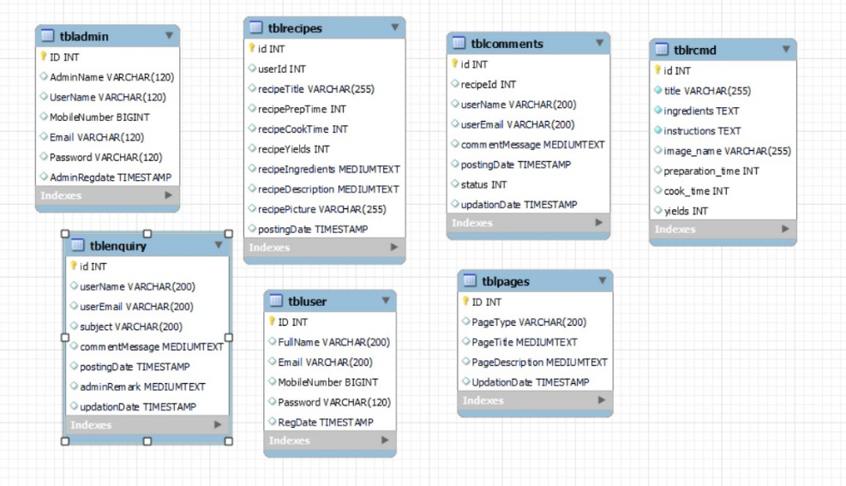

**Figure 4: Erd of our Database**

Our Database schema contains six tables:

* tblrecipes: This table stores information about recipes including a recipe title, recipe ID, preparation time, cook time, yield, recipe description, and potentially an image.
* tblrcmd: This table stores information about recipe recommendations. It includes an ID, recipe ID, title, and user email.
* tblcomments: This table stores information about user comments on recipes. It contains an ID, user ID, recipe ID, title, user name, email, comment message, posting date and potentially a status update.
* tblenquiry: This table stores user inquiries. It includes an ID, user name, user email, subject, comment message, posting date, admin remark, and update date.
* tbluser: This table stores information about users. It contains an ID, full name, email, mobile number, password, registration date, and update date.
* tblpages: This table stores information about website pages. It includes an ID, page type, page title, page description, and update date.

# **SUMMARY**

The Recipe Treasury System is an innovative system in which personalization of recipes is done according to the user's need and preference, to provide them with appropriate recipe recommendations. It addresses the requirement for easily accessible, diversified global recipes; hence, also offering the added value of an improved personalized cooking experience based on one's personal taste and needs.

We have developed a system which has a friendly interface, a recommendation algorithm, and allows the user to search for a recipe, view details about the recipe, and log in or register as a user of the site. It also has a system of commenting. The website is also easily accessible and usable on the screen of any device. An admin of the site can collect data on recipe recommendations, details about the recipe, user comments, and interaction.

# **10 LIMITATIONS AND FUTURE WORK**

**Outstanding Bugs or Issues:**

**Data Standardization**: In future work, the uniformity of recipes in terms of formatting and presentation must be done. The standardization of the lists of ingredients and methods of cooking is also expected to make them clear and accessible.

**User Interface Design**: While some effort has been made towards building an intuitive interface, more ongoing improvements need to be made for the sake of ease and platform independence of use.

**FUTURE SCOPE:**

**Personalised Nutritional Tracking:** The platform is most likely going to integrate with health applications to provide the user with recipes made according to their dietary practices and health targets.

**Cooking AI Assistants:** Will provide real-time cooking advice, on-the-go recipe modification suggestions, and cooking tips.

**Augmented Reality (AR) Recipe Experiences:** In the future, AR technology can project cooking steps right into the user's kitchen environment.

**Social Cooking Communities:** New features to be developed within the application include community interaction features that will allow the possibility of hosting virtual events or challenges for cooking.

**Voice-Activated Assistance:** Integration with voice assistants to allow hands-free use for both in-app navigation, out-of-app, and even for cooking.

# **REFERENCES**

1. **Lee, C., & Kim, Y. (2021).** Artificial intelligence for personalized cooking recommendations. AI in Food Services, 9(4), 77-92.
2. **Garcia, S., & Martinez, L. (2020).** Utilizing nutritional databases for smart recipe recommendations: A case study. Journal of Health Informatics, 18(3), 201-215.
3. **Patel, R. (2024).** Technological trends in the food industry: From farm to table. Future of Food Journal, 5(2), 130-145.
4. Smith, J., & Doe, A. (2023). User preferences in digital recipe selection and meal planning. Journal of Culinary Technology, 15(2), 45-59.
5. **Brown, F. (2022).** Augmented reality in the kitchen: Enhancing culinary skills through interactive technology. International Journal of Food and Technology, 12(1), 34-50.